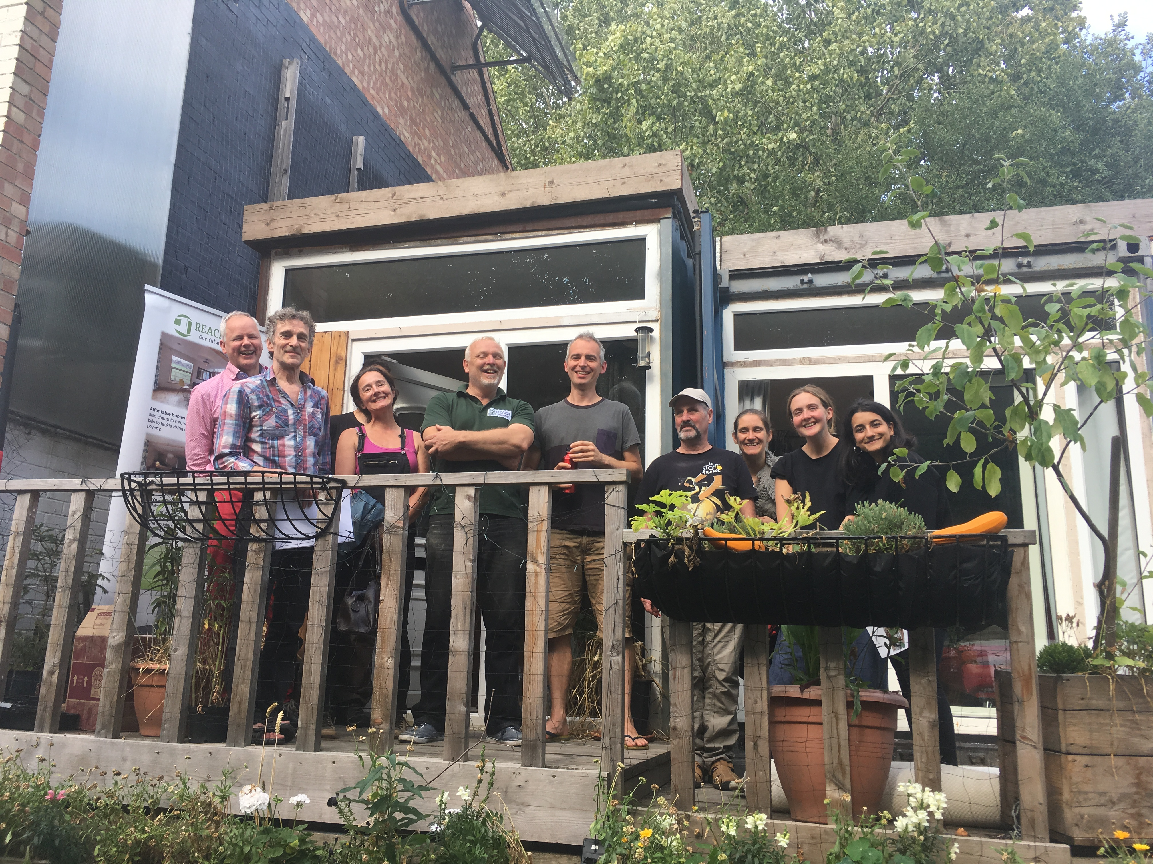
Members of the Land Justice Network visiting the house in July, keen to hear about our plans to get Homes England and the Local Gov’t Association to ring-fence public land to enable affordable projects to be built.

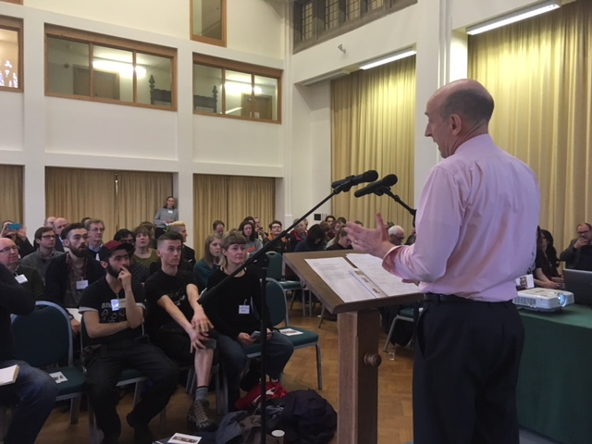
Shadow Housing Minister John Healey MP, addressing a packed conference in Sheffield in March with delegates from across the North, unveiling Labour’s new Housing Manifesto and having a great Q&A session.
Overseas students from Sheffield’s two universities getting their names on our waiting list for our novel Rent Refund model.

